**IT Project**

**Initial Report**

**Topic: E-commerce website**

**By Ramya Reddy Mothe**

# Abstract

The abstract section of the MERN stack-based website E-commerce is intended to provide a summary of what the project is generally about, mentioning its primary components and goals. Through this project, we want to construct an extremely flexible and growing E-commerce platform developed in MERN (MongoDB, Express.js, React.js, Node.js) stack. To take maximum benefits of the powerful features which both the components provide, the website aims to deliver a convenient shopping procedure to visitors that may include browsing, managing the shopping cart, secure payments, and order issuance. This project is meant to show off the effectiveness of the MERN stack in handling E-commerce applications of the present day, with all the realities of growing businesses online.

**Keywords:** E-commerce, Website development, MERN stack, User experience

**Table of Contents**

***Abstract 2***

***1.*** ***Introduction 5***

**1.1.** **Background and context 5**

**1.2.** **Problem Statement 6**

**1.3.** **Research Questions 6**

**1.4.** **Significance and motivation 7**

**1.5.** **Literature review and gap in literature 7**

**1.6.** **Structure of the paper 8**

***2.*** ***Literature review 9***

**2.1.** **MERN Stack in E-commerce Development: 9**

**2.2.** **MongoDB for Flexible Data Management: 9**

**2.3.** **Express.js for Robust Server-Side Development: 9**

**2.4.** **React.js for Dynamic User Interfaces: 10**

**2.6.** **Node.js for Scalable and Real-time Applications: 11**

**2.7.** **Inventory Management Solutions for Efficient eCommerce Operations 11**

***3.*** ***Methodology 12***

**3.1.** **Research and Requirement Analysis: 12**

**3.2.** **Design and Architecture Planning: 12**

**3.3.** **Development and Implementation: 14**

**3.4.** **Testing, Deployment, and Maintenance: 15**

***4.*** ***Result 16***

***5.*** ***Discussion 19***

***6.*** ***Conclusion, Future Works, and Recommendations 20***

***7.*** ***References 22***

**Table of Figures**

Figure 1: Data Flow Diagram 12

Figure 2: ER Diagram 13

Figure 3: Use-Case Diagram 14

Figure 4: Wireframe Homepage 15

Figure 5: Homepage UI 16

Figure 6: Product Catalogue UI 17

Figure 7: Category management 17

Figure 8: Shopping Cart UI 18

# Introduction

The E-commerce website introduction using the MERN stack, which is an innovative and robust platform that will evolve the way users carry out online shopping, is what we would like to show. Through utilizing the strength of MongoDB, Express.js, React.js, and Node.js, our website makes an easy-to-navigate and user-friendly environment. We strive to create a versatile multi-vendor marketplace range, users can explore the wide range of products, make secure transactions and have the personalized recommendations. Our E commerce site aims to reshape the Online shopping area to be the most user-friendly, reliable, and hassle - free.

## Background and context

The rise of e-commerce industry has modified the mode business follows when it comes to interacting with its customers, calling for the development of the platforms that offer excellent efficiency and scalability to deal with the online transactions. As the MERN stack represents the combination of 4 powerful technology: MongoDB, Express, React, and Node, it forms an ideal framework for creating web apps with various functionalities. The tech stack provides agility and stability that the application needs to tackle different functional complex units like, user authentication, products management, payment processing etc. MERN, in the other hand, is also modular and ease of development process while integration of features is also seamless which ensures user-friendly yet efficient shopping experience and on the part of businesses growth is propelled through effective operations management.

## Problem Statement

The problem statement of this E-commerce website development project is also highlighted in provision of a perfect platform that effectively blends the commonly used aspects of online shopping such as product listing, shopping cart management, secure payment processing, order fulfillment and many others. As more and more people resort online shopping, there needs to be sturdy and scalable technologies which users would easily adopt with the guarantee of their data security and uninterrupted operations. The goal is to optimize the strengths of the MERN stack to designed a full-featured e-commerce website that appropriately responds to the diverse requirements of customers and can successfully compete with the highly competition online retailing world.

## Research Questions

* How can the MERN stack, particularly the use of Express.Js for route control and MongoDB & Mongoose for information storage, enhance the development efficiency, scalability, and maintainability of an e-trade website in comparison to standard frameworks and facts storage strategies?
* How can the MERN stack be implemented to ensure stable consumer authentication, record encryption, and compliance with record privacy regulations inside the e-commerce website?

## Significance and motivation

It is the purpose and incentive for fashioning an E-commerce website utilising MERN technology that we will discover in its capability to provide a well-defined, scalable, and featurise app. Having MERN stack makes React.js to be able to run on the client side to create a responsive interface and Node.js also facilitates efficient server side operations therefore, ensures smooth operation of the system even during traffic peaks. MongoDB, which offer document-oriented data model, is flexible and scalable, thus making the data storage, and also retrieval of data from the system, possible. These two are particularly critical in an E-commerce setup where the product list and customer information is involved. Besides, it Express.js assists developer through streamlined development processes and you could link other services and APIs easily, as well. It should be pointed out that MERN stack provides all the fundamental tools and technologies required to develop the efficient and performant Ecommerce website that should definetely meet the expectations of both businesses and consumers while operating in the internet marketplace.

## Literature review and gap in literature

The literature review of the developer of a website earning using the MERN stack shows an ongoing study on the existing technologies and websites similar in nature. RCTs show that there are certain technologies used today to develop the dynamic and scalable e-commerce websites such as the one that MERN technology is known for. Research shows that MongoDB allows us to define a product schema and handle changes, whereas Express.js allows us to create a server for faster server-side app development. React.js is a programming language of choice for creation of engaging user interfaces while simultaneously Node.js handles a smooth communication between a client and a server. While there may be a strong body of knowledge on the specific implementation methods and best practices that help to integrate e-commerce stuffs creatively into a typical MERN-based stack, this field deserves further attention. There is the necessity for more research to find out the best options that can be used to integrate product catalog management, shopping cart functionality, payment gateways integration and order processing within the context of MERN stack e-commerce website that are getting developed.

## Structure of the paper

The report which entails the structure of the E-commerce website developed by MERN stack is organized to see all the section which explains the working process and outcomes. In the beginning of the paper I describe the significance of e-commerce for the world situation. Also, I state my purposes of choosing this technology as well as the scope of the work. The subsequent blocks discuss the website architecture and web design covering on the how w MongoDB is used as a database management tool, Express.js for server-side development, React.js for front-end user interface and Node.js for backend server operations. Secondly, the report contains the chapters which give specifics about features and functionalities that have been built into the website like product catalog administration and user authentication together with payment gateway integration. On the top of this, specific tools like testing approach, optimization techniques, and deployment strategies are explicitly addressed. The report ends with a personal reflection of the challenges one came across, the lessons that one learned and additional recommendations for the project.

# Literature review

## MERN Stack in E-commerce Development:

The so-called MERN (MongoDB, Express.js, React.js, Node.js) stack has been chosen by many expensive e-commerce website owners as it helps them to become scalable and also similarly versatile. Statistics and many researches have endorsed the positivity of using MERN as a basis for dynamic web applications and user-friendly e-commerce platforms Panda SK (2016).

The researchers have pointed-out how MERN's modularity makes it possible to streamline components. Developers can then integrate them seamlessly and develop web applications with exciting user experiences for online shopping the consumers can interact with.

## MongoDB for Flexible Data Management:

According to Kuan H & Vathanophas V (2018 ) e-commerce application, MongoDB is the component handling database within the MERN stack. MongoDB has that capability of handling data efficiently providing flexibility and scalability.

MongoDB's document-stacked structure has been praised in literature for devoting a better environment to assemble and call every complex product data specifications, customer accounts, order transactions and product catalogues. Academicians conducted studies on MongoDB's features as it helps process massive volumes of data fast, giving online shopping websites with extensive product catalogs and user databases the appropriate performance.

## Express.js for Robust Server-Side Development:

Express.js is a web application framework for writing a server side of apps, and it is an important part of e-commerce website development in the Node.js environment. Research has underlined the fact that Express.js has a crucial role to play in providing a streamlined process for the creation of RESTful APIs and the middleware component facilitating effective communication among the client-side and server-side aspects of the application. as per researchers ( Surya G et al 2023 ) Express.js playhall role in ensuring security and data integrity processes through authentication, authorization and data validation for ecommerce transactions.

## React.js for Dynamic User Interfaces:

React.js, the front-end library of MERN stack which has a strong backend, helps develop websites with super-responsive and dynamic User Interface’s by Angela L et al (2021). A prevailing theme which literature discusses is the fact that React.js's component architecture facilitates the creation of reusable UI elements, thus contributing to improved scalability and maintainability of online stores.

Researchers looked into React.js that allows to make the usability of a platform better by providing features such as real time update, product catalogue viewing and user friendly navigation which consequently improve user engagement and conversion rates(Aakash et al 2018 ).

## 

## Node.js for Scalable and Real-time Applications:

Amid the server-side enactment of JavaScript execution environment Node.js, scalability and performance output are the ones that identify the e-commerce websites. Research revealed Node.js's single-threaded event-driven model to be a great asset for creating high-traffic and real-time applications necessary, for example, to manage concurrent web service transactions invoked by many users interacting with e-commerce environments. Researched by (Yadav & Dhakad S et al. 2019), the role of Node.JS in optimizing server on-the-side performance, decreasing response times, and perfecting seamless integration with third-party APIs and services which enrich the functionality and performance of e-commerce websites has also been covered by researchers.

## Inventory Management Solutions for Efficient eCommerce Operations

In an e-commerce environment, efficient inventory management not only enables the retailers to have a sufficient number of products to fulfill orders in timely but also boosts consumers' satisfaction index. (Harrison C ) The literature review concentrates on the inventory management solutions suitable for the MERN stack, their features, their integration with the MERN stack, and their impact on the organization's performance.

By giving attention to the investigation of the novel findings and trends happening in the market, our team will define how to track the stock, replenish the stock, and manage the flow of orders within the MERN stack setting.

Similarly, we will discuss techniques of real-time inventory updates, automatic notifications when the stock is low, and integrating it with other eCommerce capabilities for a smooth operation. For the same reason, we will also improve the performance of all the business operations.

# Methodology

## Research and Requirement Analysis:

Methodology sets off from a thorough research to clarify the peculiarities and the requirements which are needed to build winery’s e-commerce site. This includes processing market trends, studying competitors, and knowing users’ interests to make a list of required features and performance factors. Not only are requirements collected from stakeholders and users via consultations and user interviews to keep the business goals and user needs synchronized, but they are as well. Herein we will hash out the framework and outline the scope, the objectives, and user stories of the e-commerce website for the Samsung 7 smartphone.

## Design and Architecture Planning:

The designers will move on to analyse the requirements after which the architecture and user interface of the e-commerce website are framed. MERN stack ((MongoDB, Express.js, React.js, and Node.js) is chosen for its scalability, adaptability, and performance due to its characteristics such as. Architecture design is modular, modular, scalable, and secure; the main priority is to make the site able to take care of massive transactions and heavy traffic easily. User interface design is all about creating a versatile and nice-looking structure that is usable and alluring, hence, encouraging interaction and engagement with the user.

*Figure 1: Data Flow Diagram*

The Data Flow Diagram (DFD) visualizes the flow of data within the E-Commerce Website, depicting the processes, inputs, outputs, and data stores involved in managing e-commerce operations.

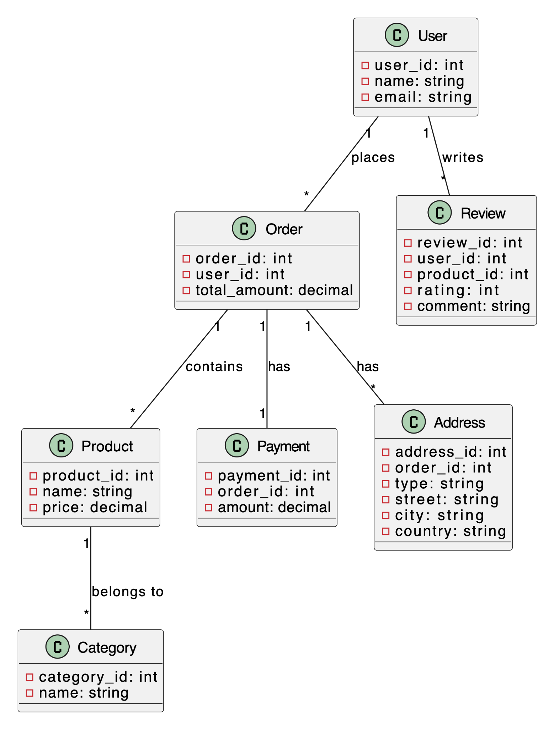

*Figure 2: ER Diagram*

The Entity-Relationship (ER) Diagram illustrates the logical structure of the database schema used in the E-Commerce Website. It outlines the entities (such as users, products, orders, and payments) and the relationships between them.

## Development and Implementation:

And during the development stage, the process moves to its next phase, i.e. the architecture and the design. It would be developers using the MERN stack who would do the building by creating all sorts of components for the e-commerce website (including the front-end user interface, back-end functionality, and database integration).

Agile approach to development is practiced, which utilizes Scrum and Kanban mantras in order to enable iterative advancement, iterative feedback loop and continuous improvement. Such iterative concept makes it possible for developers to tackle with any given issue or modification of the requirements promptly and reliably release the E-commerce web site at the right time.

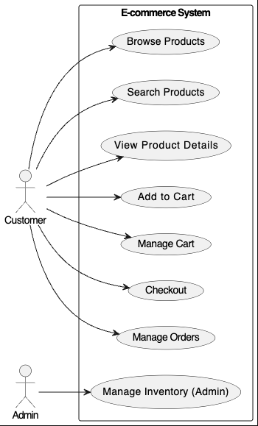

*Figure 3: Use-Case Diagram*

The Use-Case Diagram provides a visual representation of the various interactions between users and the E-Commerce Website. It outlines the different use cases or scenarios that users can perform within the application, such as browsing products, adding items to the shopping cart, placing orders, and making payments.

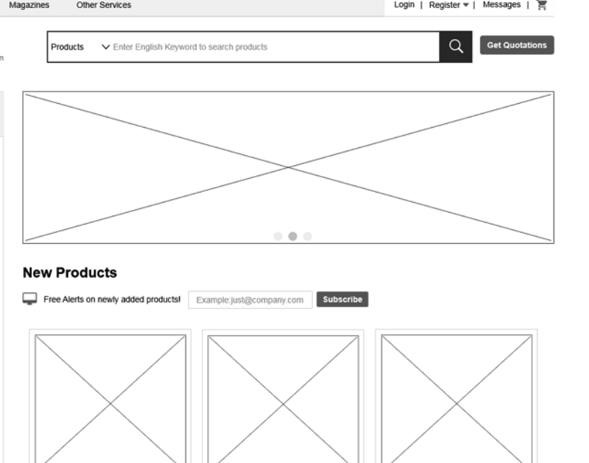

*Figure 4: Wireframe Homepage*

The Wireframe Homepage provides a schematic representation of the homepage layout and structure of the E-Commerce Website. It outlines the placement of key elements such as navigation menus, product categories and featured product.

## Testing, Deployment, and Maintenance:

The concluding stage entails drastic website performance checking like its ability to operate, speed, and security. These operations are integrated to include unit testing, integration testing, and user acceptance testing to identify and solve any problems that are present. After testing has been finished, website deploying to the production atmosphere is started, and monitoring tools are used to track performance and the activity of users. Continuous maintenance and troubleshooting are played out, thereby meeting the issues that may arise after the deployment and bringing new features or improvements by incorporating user feedback and current business requirements.

# Result

The e-commerce website using the MERN stack has been developed over such days and has yielded promising outcomes. The cartridge architecture of the platform, based on the MongoDB, Express.js, React.js, and Node.js technologies, allowed the successful development of a new e-commerce project with many advanced and scalable features. Implementation of these critical functionalities, such as product catalog management, user authentication, and responsive web design, are completed to ensure their function on different devices with no problem.

While some challenges occurred during the development process, affecting the project's outcome, such as refining the performance and securing the product, our team developed strategies to break through those tasks and work accordingly to meet the project’s requirements. The use of continuous integration and testing has been promoted throughout the cycle.

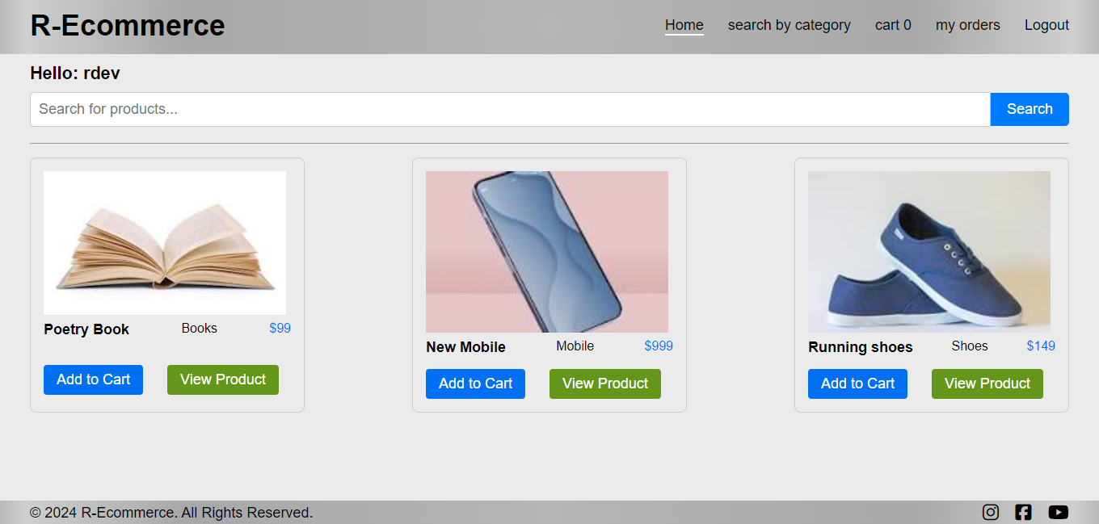

*Figure 5: Homepage UI*

The Homepage UI showcases the visual design and user interface elements of the homepage of the E-Commerce Website. It depicts the finalized layout, typography, colors, and graphical elements used to create an engaging and intuitive user experience.

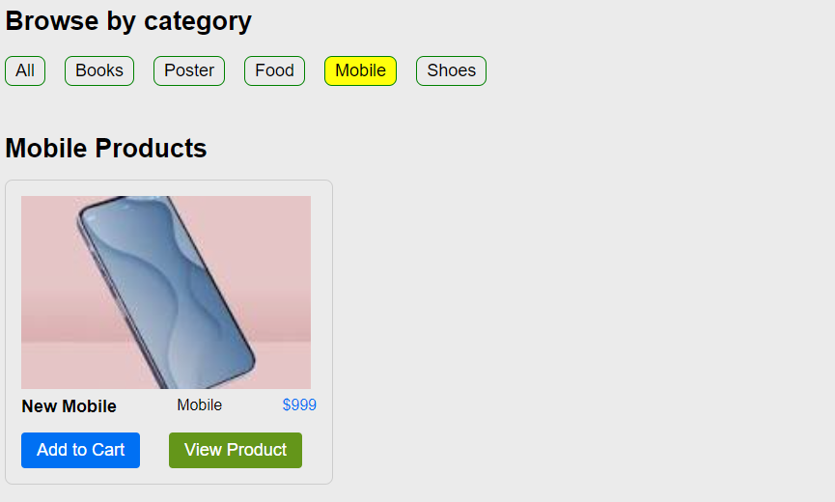

*Figure 6: Product Catalogue UI*

The Product Catalogue UI presents the visual design and user interface elements of the product catalogue page within the E-Commerce Website. It displays a grid or list of products with accompanying images, titles, prices, and filtering options.

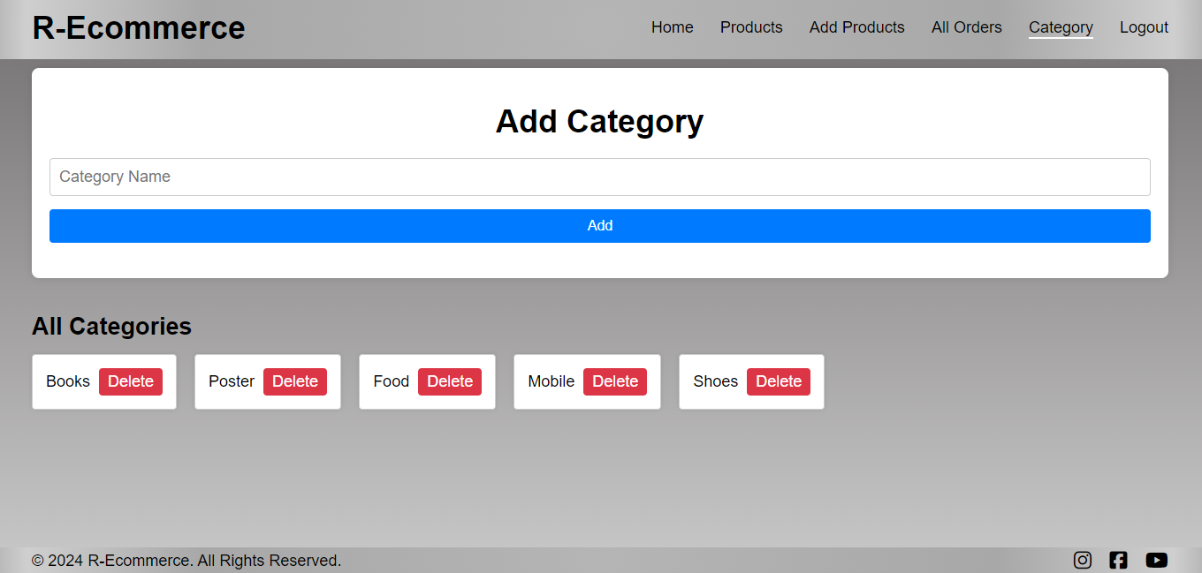

*Figure 7: Category management*

The Product Filter Header UI showcases the visual design and user interface elements of the product filter header section within the E-Commerce Website.

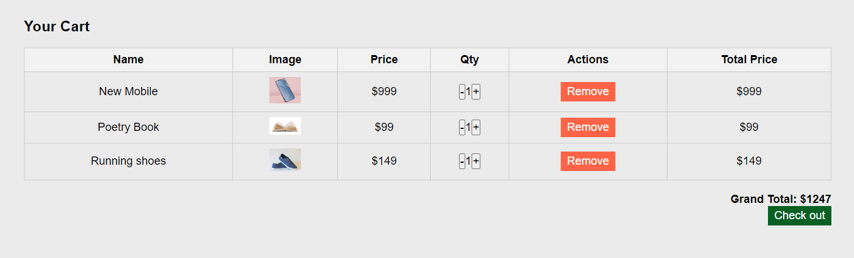

*Figure 8: Shopping Cart UI*

The Shopping Cart UI displays the visual design and user interface elements of the shopping cart page within the E-Commerce Website. It showcases the items added to the cart, along with quantity, price, and subtotal for each item.

Bugs that can scare customers are identified and rectified early in development. Hence, there is an assurance of high code quality and reliability. However, the technical team will continue dedicatedly to perfect the user interface, fortifying the security, and integrating extra functionality like personalized recommendations and social media, thus further facilitating the website user experience and engagement. With a sufficient scheme and a high level of execution, this project will give an innovative e-commerce platform that will correspond to the clients' and consumers' requirements and expectations.

# Discussion

The MERN stack eCommerce website application development marks an actor important step towards the embodiment of a firm and elastic virtual environment. The choice of the MongoDB for database management, Express.js for backend development, React.js for frontend design, and Node.js for server-side scripting is a strategic selection to build a system with an assorted number of attributes and quality performance. Taken all together, the technologies provide the base for which a highly featured and apt eCommerce option can be tailored to satisfy the dynamic requirements of the users as well as businesses.

Although implementation of such features is a crucial execution that must be handled meticulously to avoid any hitch. These elements represent a true playing ground to expand the store and promote business development, however, every privilege comes with its own duties, such as when it comes to secure data and processing integrity. It is crucial to develop robust security measures to give users peace of mind before and after their transactions to create trust and confidence, this will in the long run keep clients and potential users decked.

Along with that, it is necessary to ensure that the design, development, and testing teams work hand in hand to come up with user friendly platform that runs smoothly. Through a spirit of cooperation and horizontal communication across various team’s members, teams can synergize their collective experience and imagination to overcome obstacles, find new directions, and provide outstanding results. This innovative method enables not only fulfilment of the goals of the eCommerce platform but outperforms user’s expectations, which promises effectiveness over a longer period of time in the fierce online market environment.

# Conclusion, Future Works, and Recommendations

Finally, developing a MERN stack eCommerce website creates a favourable environment for contributing to the future digital economy. The next stage is to keep improvement and updates constantly present to meet the changing demands of customers and technology. A MERN stack-based website development for the E-Commerce business will bring about a revolutionary change to unfold a blossoming era for the Digital Commerce era. From now on, we are going to concentrate on keeping the culture of continuous perfection and innovation that will better involve the manifesting needs of users and the cutting-edge tech.

Here next, the process gets evolutionary, so it is imperative to understand the importance of user experience. This can be achieved through the personalized product recommendations as well as the AI chatbots for customer support, and analytics tools for the deep analysis and intelligence operation. These attributes will be the cornerstone of our design and will be employed to make the entire purchasing journey more exciting and to boost consumer loyalty to the utmost.We will be in position to undertake regular checks and balances of the website performance measures, security systems, and scalability policies as part of the growth and customer satisfaction sustenance. Through meticulous evaluation and removal of any performance inhibitors or security breaches, we can ensure the continuance of the system's high performance and reliability.

The other important thing is to put a good feedback system in place in order to gather insights from our consumer audience which will help to plan for improvements and optimizations. Through emailing customer feedback and using their comments when we design a better customer experience for their likings and tastes in such a way they will be satisfied and at the same time, they will feel they have an impact.

Furthermore, ensuring that everyone on the development team has an environment to work in where they can stimulate their minds, collaborate with others and overcome challenges will be key to the growth and success of the E-Commerce platform in the long run. Thought by providing brainstorming sessions, pride-sharing and multidisciplinary work, we recognize the collective knowledge and creativity among our team which is capable to solve the complications and capture the new opportunities arising out.

In a nutshell, the end goal is to encourage a culture of continuous improvement, innovation and collaboration so that MERN stack E-Commerce Website becomes the leading player in the digital market space and the customers are the ultimate ones to enjoy top class experience and services that drive sustainable growth and success of the business.

We will delve deeper into various ways of improving user experience, e.g., personalized product suggestions, implementing AI-powered chatbots in customer support, and adding analytics tools for analysis and business intelligence operations. Moreover, frequent observing or metrics of website performance, security, and scalability must be deeply rooted to achieve lasting growth and customer satisfaction. It should be done to place a feedback system to collect the audience's insights and adopt improvements on the experience based on this feedback. Not only does this, but creating an environment for innovation and teamwork among development team members also helps solve problems over time and keeps the eCommerce platform extremely successful.

\

# References

*Turban, E., & Gehrke, D. (2019). Determinants of e‐commerce Website. Human Systems Management,* 19(2), 111–120. <https://content.iospress.com/articles/human-systems-management/hsm421>

Panda, S. K. (2016). An Investigation into Usability and Productivity of ECommerce Websites. University. <https://shodhganga.inflibnet.ac.in/handle/10603/123505>

*Kuan, H.-H., Bock, G.-W., & Vathanophas, V. (2008). Comparing the effects of website quality on customer initial purchase and continued purchase at e-commerce websites. Behaviour & Information Technology,* 27(1), 3–16. <https://doi.org/10.1080/01449290600801959>

Surya, G., S. Ayesha Amrin, S. Sushma, S. Mahalakshmi, & A. Monisha. (2023). An efficient Ecommerce website using product listing and A9 algorithm. Nucleation and Atmospheric Aerosols. <https://doi.org/10.1063/5.0179063>

Sudiana, Chandra, Y. U., & Angela, L. (2021). Key Success Factors for a Better User Experience in E-Commerce Website. 2021 International Conference on Information Management and Technology (ICIMTech). <https://doi.org/10.1109/icimtech53080.2021.9535076>

*Aggarwal, A. G., & Aakash, N. A. (2018). Multi-criteria-based prioritisation of B2C e-commerce website. International Journal of Society Systems Science,* 10(3), 201. <https://doi.org/10.1504/ijsss.2018.093940>

THE IMPACT OF DOMAIN-SPECIFIC STOP-WORD LISTS ON ECOMMERCE WEBSITE SEARCH PERFORMANCE - ProQuest. (n.d.). Www.proquest.com. Retrieved February 26, 2024, from <https://search.proquest.com/openview/86b79ed0aada9ba3ba66a15b04b32341/1?pq-origsite=gscholar&cbl=38874>

EBSCOhost Login. (n.d.). Search.ebscohost.com. Retrieved February 26, 2024, from <https://search.ebscohost.com/login.aspx?direct=true&profile=ehost&scope=site&authtype=crawler&jrnl=23832126&AN=116294575&h=pZkEdr1NlxmBGbwpMHQyDjOj5Ox7yy6ubgJ5odc7JtkpfZO06sdzowGovqQu38%2Fu3z7KL6Q0pZOB1OOLmTSkFw%3D%3D&crl=c>

Yadav, N., Rajpoot, D. S., & Dhakad, S. K. (2019). LARAVEL: A PHP Framework for E-Commerce Website. 2019 Fifth International Conference on Image Information Processing (ICIIP). <https://doi.org/10.1109/iciip47207.2019.8985771>

Relationship Development Process in eCommerce Websites | IEEE Conference Publication | IEEE Xplore. (n.d.). Ieeexplore.ieee.org. Retrieved February 26, 2024, from <https://ieeexplore.ieee.org/abstract/document/9677208/>

Harrison, C., & Petrie, H. (n.d.). Severity of Usability and Accessibility Problems in eCommerce and eGovernment Websites. People and Computers XX — Engage, 255–262. <https://doi.org/10.1007/978-1-84628-664-3_19>

Wu, Z., Shen, S., Zhou, H., Li, H., Lu, C., & Zou, D. (2021). An effective approach for the protection of user commodity viewing privacy in e-commerce website. Knowledge-Based Systems, 220, 106952. <https://doi.org/10.1016/j.knosys.2021.106952>